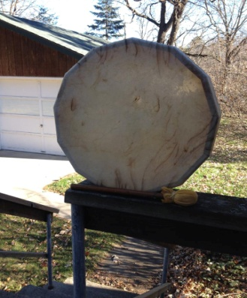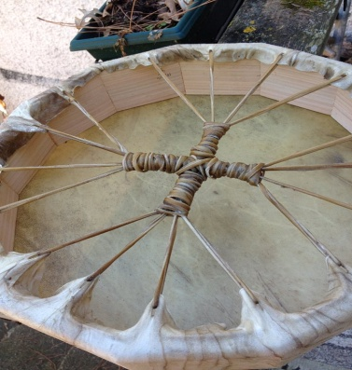
Drum Making Class (15” Elk Hide Drum and Beater)
With Jeanne Marie Troge, MA Shamanic Practitioner
Saturday, April 28th, 2018 9:30-3:30pm (1 hr lunch break)
Class held at Elevated Wellness, 113 W. Broadway St., Monticello MN 55362
$195 per drum, $100 to be paid at time of registration, deadline April 7th. Registration/payment to be sent to: Jeanne Troge, 614 Forest Ave, Park Rapids, MN 56470 by April 7th. This gives time to order supplies. Checks should be made out to Jeanne Troge.
The beat of the drum is the heartbeat of Mother Earth, and connects us to our own heart. Making a drum is really a transformational journey into our own hearts. It is a voice that is birthed with spirit and the love that comes from the sacrifice of the elk and the tree. In this class we will meet the spirit of our drum and will learn how it is to be used in our life. We will also discover the spirit animal of our drum.
You will be making a 13 sided, 15” elk hide frame drum and accompanying beater. April 29th is the full moon so your drum will be infused with the #13 of the Goddess and the full moon lunar energies! It is a powerful time to make a drum.
All materials will be provided and are included in the price of the workshop. If you have some special beads or feathers you’d like to put on your drum you can bring those too. Early registration including $100 payment for the class is required so that supplies can be purchased. The remaining $95 can be paid on the day of the class. Class size is limited.
Drumming has many benefits to body and soul. Drumming at 220-260 beats a minute puts your brain waves into an alpha or theta state where you are deeply relaxed and may even receive visions. Drumming can help reduce stress and is great for addressing anger issues. You may contact Jeanne at earthdrummer@hotmail.com for more info or questions.

